**Synopsis Abstract:**

-A prominent problem in parking lot is that it becomes difficult in night to find the vehicle in a big parking lot having thousands of vehicles, so to simplify the task of finding the vehicle in parking lot, we are introducing a new web-based solution which will make it easier to find vehicle in the parking lot, just by entering the customer's name and vehicle no. onto the website, the customer will be able to find a vacant slot and also it will be easier for them to locate afterwards where the vehicle was parked.

**Literature Review/Existing Innovation-technology to address related to your problem:**

**-According to the existing system for parking, the parking slips are used to allot the slot for parking to the users, and user has to remember where their vehicle was parked and using this method it becomes difficult to find vehicle specially in the night conditions.**

**What would be your approach to solve the problem:**

**-In our approach, The parking lot will be divided into two blocks for Two-Wheeler, Four-Wheeler. There will be separate slots for each vehicle in both the blocks. The user will require to login to the website. The user will be provided the layout of the parking lot on the website from which the parking slots will be alloted to the user, after alloting the parking slot, the user will receive a text message containing the information regarding the alloted slot, in this way the problem of locating the in the parking will be solved.**

**Road map/Flow diagram to develop final solution (1)**

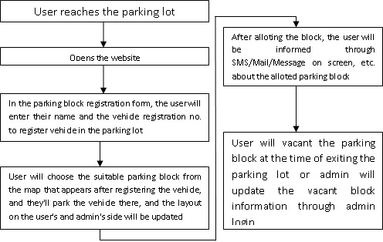

**Road map/Flow diagram to develop final solution (2)**

**Tools and technologies to be used to solve the problem:**

**-PHP Scripting, Apache Server, MySQL Database Server, JavaScript, Bootstrap CSS, HTML.**

**Challenges/Risk in implementing your Final prototype:**

**Possible outcome of your work:**

**-The problem of locating the vehicle in the parking lot will be solved.**

**-The user can easily get the parking slot.**

**Work done till date**

**Image/Screenshot of Solution (1)**

**Image/Screenshot of Solution (2)**

**(Report in PDF)**